**IT5016 - Software Development Fundamentals**

**Week 4 - Session 2- Lab**

**FUNCTIONS**

**Objective:** To reinforce understanding of functions, parameters, and the concepts of local and global variables through practical coding exercises.

**Task 1: Simple Function**

1. Copy out the simple example shown and make sure that it runs.

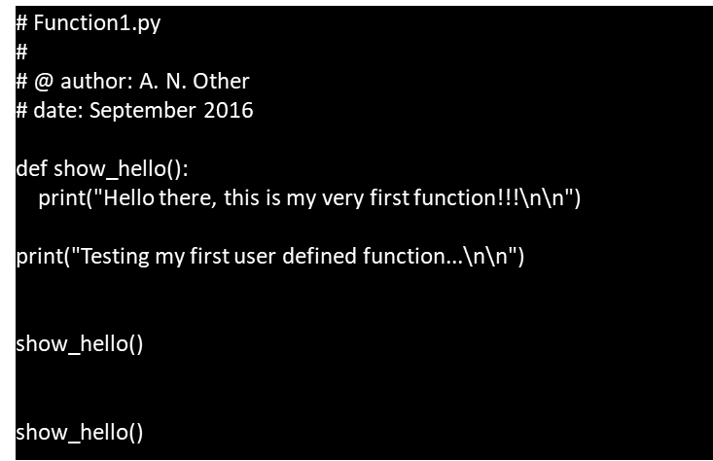

1. Change the text, and run the program again.
2. Write a program that displays a welcome message, then displays the result of adding 2 integers. The integers must be defined in the add_numbers( ) function.
3. Write a program that stores an integer value x and a string of value y (you can choose these values) The program must use a method that displays the y text, x number of times.
4. Write a simple program that outputs a random number to the screen every time the user types r. If the user types anything else then the program should terminate.

**Task 2: Functions with Parameters**

Often we need to pass data to a function. The syntax for this is shown in the example below.

"A function can use a variable from outside its code block by taking that variable as a function parameter."

Run this program:

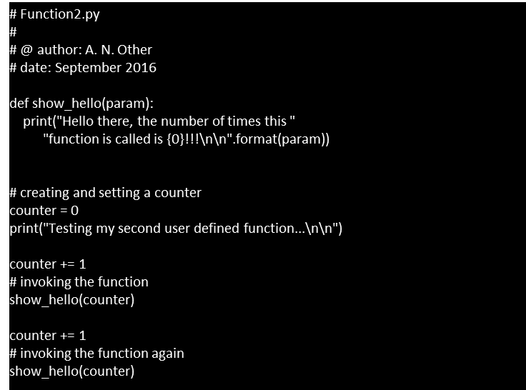

**Task 3: Function Creation and Parameter Usage**

Create a Python program that calculates the area of a rectangle using a function. The function should take two parameters - length and width. Use the following steps:

* Define a function named calculate_rectangle_area that accepts length and width as parameters.
* Inside the function, calculate the area of the rectangle using the formula area = length * width.
* Return the calculated area from the function.
* Outside the function, take user input for length and width.
* Call the calculate_rectangle_area function with user-provided values and display the calculated area.

**Task 4: Local and Global Variables**

Extend the previous program by introducing local and global variables. Modify the program as follows:

* Declare a global variable named global_var and assign it a value (e.g., 10).
* Inside the calculate_rectangle_area function, declare a local variable named local_var and assign it a value (e.g., 5).
* Display the values of both global_var and local_var inside the function and observe the scope differences.
* Display the values of global_var and local_var outside the function and observe how local variables do not affect the global scope.

**Task 5: Function with Default Parameters**

Create a function named greet_person that greets a person using their name. The function should take two parameters - name (required) and greeting (optional, default value: "Hello"). Use the following steps:

* Define the function greet_person with parameters name and greeting="Hello".
* Inside the function, generate a message by combining the greeting and name parameters.
* Return the generated message.
* Call the function with only the name parameter and display the default greeting.
* Call the function with both name and greeting parameters and display the customized